Beaches Chapel School Event Permission Form
Enchanted Forest Banquet
February 21, 2025
6:30 pm – 9:00 pm

Beaches Chapel School wants every student to have a safe and enjoyable experience at all of our events. To ensure this, we are asking Beaches Chapel students and guests to follow the policies outlined in the BCS Family Handbook, as well as those outlined below. Please complete the form below and return it to the appropriate school office.

Event Name: Enchanted Forest Banquet______________ Event Date: February 21, 2025
Event Location: BCS Impact Center 610 Florida Blvd
I understand that I must abide by the rules set forth by Beaches Chapel School which include but are not limited to:
- I will not use, possess or promote the use of tobacco, drugs, alcohol or weapons.
- I will not be disrespectful to any student or adult.
- I will not engage in inappropriate displays of affection or lewd acts.
- I understand that this event is a “lock-in” activity, meaning, I will not be allowed to leave the event and re-enter until the end of the event.
- I understand that I may not attend the event if I am 21 years of age or older, unless I am a pre-approved chaperone for the event.
- I understand that once I leave the dance I am no longer allowed re-entry.
BCS Student:

Name (Print): __________________________________________ Grade: _______________ Student Signature: ____________________________________________

BCS Guest:

Name (Print): __________________________________________ Grade: _______________ Student Signature: ____________________________________________

Beaches Chapel School Liability Release and Medical Consent Form

As parent(s) or legal guardian(s), I hereby give permission for my child__________________________ to participate in the above-named activity.

I, and my child, do hereby release, forever discharge, and agree to hold harmless Beaches Chapel Church and School, and the directors, employees, its agents and all other persons associated with Beaches Chapel from any and all liability, claims or demands for personal injury, sickness or death, as well as property damage and expenses, of any nature whatsoever which may be incurred by the undersigned (and the participant, if a minor) while said persons are in the care of Beaches Chapel Church or its leaders.

I understand that, in the event my child requires medical or dental treatment while engaged in the Activity, reasonable efforts will be made to contact me. However, if I cannot be reached, I hereby give consent and give permission to Beaches Chapel leaders, or any adult leader acting on behalf of the Church, to act as an agent for me. They may consent to any treatment and care advised and supervised by a physician, a surgeon or a dentist in an emergency.

In the event of the necessity of the administration of first aid and/or a doctor’s care, or any other form of medical treatment necessitated by illness or injury, the undersigned agrees to hold harmless and indemnify said church, its directors, employees, agents and all other persons associated with Beaches Chapel from any acts of malfeasance, and/or failure to act on the part of those chosen to administer medical care on behalf of the participant.

Student Emergency Contact Information:

Parent/Guardian Name_____________________________ Cell Phone______________ Home Phone__________

Parent/Guardian Name_____________________________ Cell Phone______________ Home Phone__________

Other Person ___________________________________ Cell Phone______________ Home Phone___________

Guest Emergency Contact Information:

Parent/Guardian Name_____________________________ Cell Phone______________ Home Phone__________

Parent/Guardian Name_____________________________ Cell Phone______________ Home Phone__________

Other Person ___________________________________ Cell Phone______________ Home Phone___________

“I have carefully read the foregoing release form and know the contents thereof, and I agree to and sign this release as an act of my own free will.”

Parent/Guardian Signature: _______________________________________________Date:________________

Guest Parent/Guardian Signature: __________________________________________Date:________________

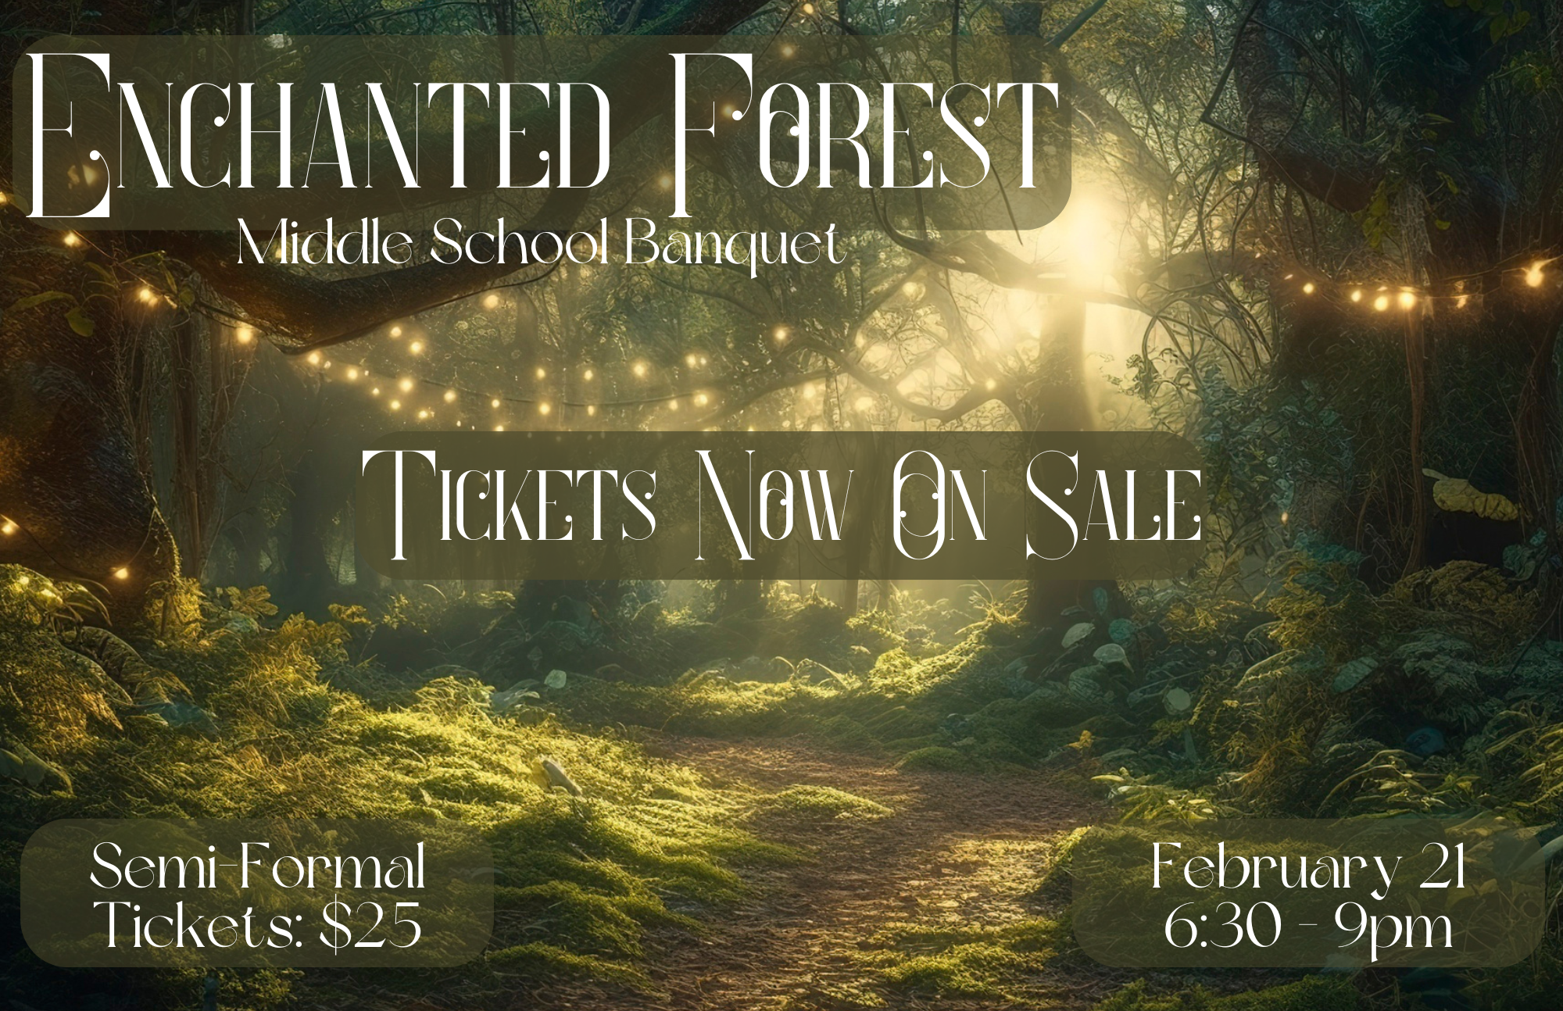
Middle School Banquet Dinner 2025
This year, the Middle School Dance will be on Friday February 21st, at the Beaches Chapel Impact Center in Neptune Beach. We cordially invite you to attend the Middle School Banquet. Doors open at 6:30pm and the banquet will last until 9:00.

- Tickets may be purchased from Feb 10-19th in the Upper School office.
- Tickets are $25 per person. Tickets will NOT be sold at the door. Only BCS Middle School students may purchase tickets. You may only purchase one additional ticket (at the same price as your own ticket).
- A student from another school may attend as a guest but must be in 6th -8th grade. Guests must also complete the permission slip attached. Guests enrolled in another middle school or home school must have parent permission.
- Dressy-casual attire is required. Ladies, dresses should be appropriate for a school function. Gentlemen may wear dress pants with button-up shirts.
- Dancing and behavior must remain appropriate throughout the evening.

Very Important Note:

Anyone who attends the banquet under the influence of alcohol or drugs will face serious consequences. This is a school event. There will be zero tolerance for students under the influence or in possession of drugs or alcohol. Students under the influence will be charged with a Class IV or Class V violation of the Student Code of Conduct. Please make wise choices to ensure a safe event for everyone.

The above letter applies to BCS students as well as their guests. All information on the back of this form must be completed before tickets may be purchased. If bringing a person who does not attend BCS, this form must be submitted by Feb 19th.

